Year 4 Music: What is an Orchestra? Autumn One
What should I already know? | What knowledge and skills will I learn by the end of this unit? | Key Vocabulary
- I understand the stave, lines and spaces and can use dot notation to show higher or lower pitch  - I understand the differences between crotchets and paired quavers  - I can sing a widening range of unison songs and perform actions to them confidently  - I can walk, move or clap a steady beat with others, changing the speed of the beat as the tempo of the music changes  - I can structure musical ideas to create music that has a beginning, middle and end.  - I can copy stepwise melodic phrases with accuracy at different speeds. | - I can recognise and identify most of the instruments of the orchestra  - I understand how sound is produced  - I know how families of instruments are grouped in a standard orchestra set up  - I can play a variety of pitched and unpitched instruments and experiment with how they make sounds  - I can clap and copy simple rhythms accurately.  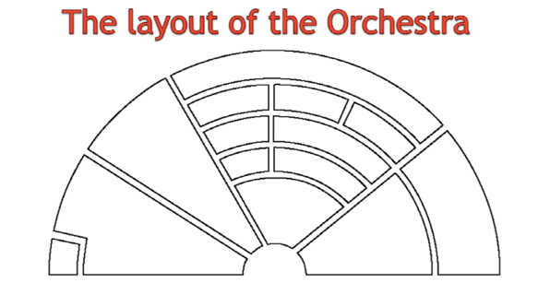  - I can sing a song with accuracy and perform it in a group with other parts. | Pizzicato | Plucking the strings of an instrument rather than using a bow
 |  | Orchestra | A large group of mixed instruments playing together including strings, woodwinds, brass and percussion
 |  | Conductor | The leader of the orchestra
 |  | Embouchure | The mouth shape and strength you need to play a wind or brass instrument
 |  | Reed | A slim piece of cane or bamboo that some wind instruments use to produce sound.
 |  | Percussion  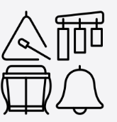 | Different rhythms or melodies played at the same time as each other
 |  | Ensemble  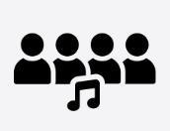 | Off-beat rhythm patterns

